Validator screenshot 1ST TIME

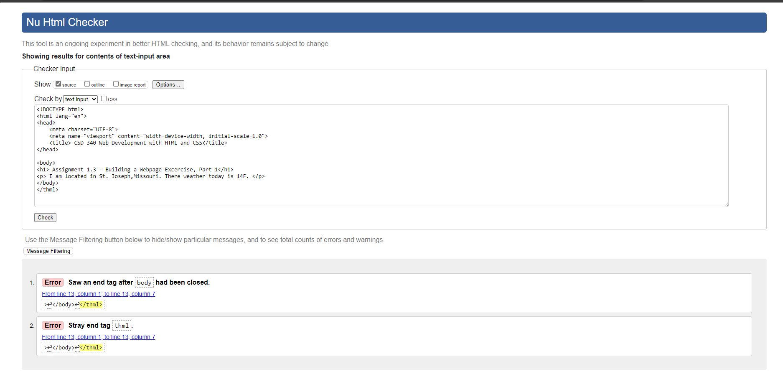

Updated Validator ScreenShot

Final Validation

Web Page Output

